# Investigation 01: Nmap SYN Scan Detection

## Executive Summary

This investigation demonstrates the detection and analysis of network reconnaissance within a controlled cybersecurity home lab. A Kali Linux system at `192.168.40.100` performed an authorized Nmap TCP SYN scan against a Windows 11 system at `192.168.40.101`. The scan identified TCP ports 135, 139, and 445 as open on the Windows host.

Security Onion monitored the network traffic through its passive monitoring interface. Suricata generated multiple scan-related alerts, while Zeek recorded connection telemetry that was used to investigate and correlate the activity. Analysis of the telemetry confirmed communication from the Kali system to numerous TCP ports on the Windows system, including the three ports identified as open by Nmap.

The activity was determined to be authorized reconnaissance performed as part of the lab exercise. No evidence collected during this investigation indicated that the Windows system was compromised. This exercise demonstrates network traffic analysis, IDS alert triage, event correlation, and basic SOC investigation methodology.

Lab Environment and Network Architecture
The SOC home lab was built using VMware Workstation to simulate a segmented enterprise network. pfSense was configured as the primary router, firewall, DHCP server, and gateway between the virtual networks. Security Onion was deployed as the network security monitoring platform and configured with separate management and monitoring interfaces. Kali Linux served as the authorized security testing system, while Windows 11 served as the monitored endpoint. This architecture allowed controlled security activity to be generated from Kali, observed by Security Onion, and investigated using Zeek and Suricata telemetry.

NETWORK ARCHITECTURE
System | IP Address | Network | Purpose
pfSense WAN | 192.168.34.128 | VMnet8 | Internet/NAT
pfSense LAN | 192.168.22.254 | VMnet1 | Management gateway
pfSense OPT1 | 192.168.40.254 | VMnet2 | Monitored network gateway
Security Onion | 192.168.22.10 | VMnet1 | SOC management
Security Onion ens192 | No IP | VMnet2 | Passive monitoring
Kali Linux | 192.168.40.100 | VMnet2 | Security testing
Windows 11 | 192.168.40.101 | VMnet2 | Monitored endpoint

VMnet1 (192.168.22.0/24) was used as the management network, while VMnet2 (192.168.40.0/24) was used as the monitored lab network. pfSense OPT1 (192.168.40.254) provided DHCP, routing, and firewall services to the monitored network. Security Onion's ens192 interface was attached to VMnet2 without an IP address and operated as a passive monitoring interface. Testing with tcpdump confirmed that Security Onion could observe traffic between Kali Linux and Windows 11 before the SOC
Reconnaissance Procedure
To simulate network reconnaissance, an authorized TCP SYN scan was initiated from the Kali Linux system (192.168.40.100) against the Windows 11 endpoint (192.168.40.101). Nmap was used to scan commonly used TCP ports on the target. The purpose of the test was to determine which services were accessible on the Windows endpoint and evaluate whether Security Onion could detect and record the reconnaissance activity.

sudo nmap -sS 192.168.40.101

The -sS option instructs Nmap to perform a TCP SYN scan. The scan identified three open TCP ports on the Windows 11 system: TCP/135 (msrpc), TCP/139 (netbios-ssn), and TCP/445 (microsoft-ds). The remaining scanned ports were reported as closed.
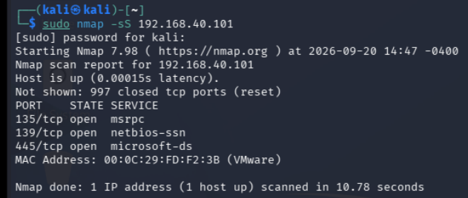
Figure 1 — Nmap SYN Scan Results: Nmap identified TCP ports 135, 139, and 445 as open on the Windows 11 endpoint.

Security Onion Detection
Following the Nmap SYN scan, the Security Onion Alerts dashboard was reviewed to determine whether the reconnaissance activity generated IDS detections. Prior to the scan, Security Onion displayed 69 total alerts across three alert groups. After the scan, the dashboard displayed 76 total alerts across 10 alert groups, indicating that seven new alert groups had appeared following the test activity.
Suricata generated multiple scan-related alerts associated with the reconnaissance activity. These included detections involving MSSQL TCP/1433, Oracle SQL TCP/1521, PostgreSQL TCP/5432, MySQL TCP/3306, and the VNC port range. These detections demonstrated that Suricata signatures recognized portions of the Nmap-generated traffic as potentially suspicious scanning behavior.
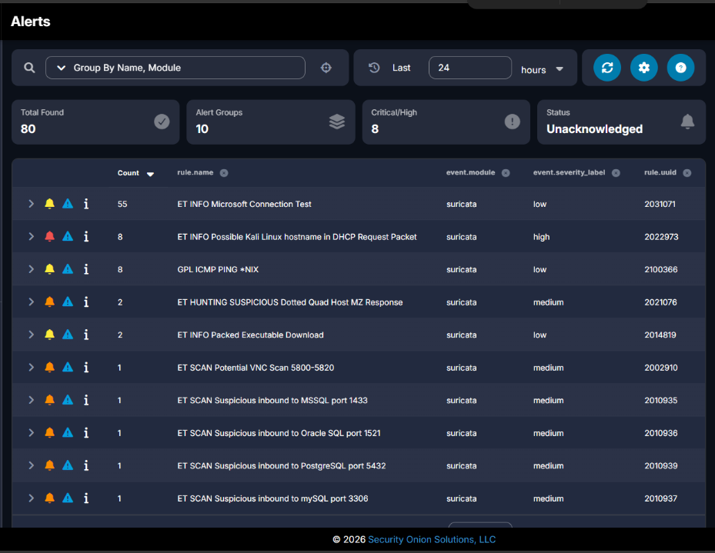
Figure 2 — Security Onion Alerts: The Alerts dashboard after the Nmap scan shows multiple new scan-related Suricata detections.

The presence of an IDS alert does not by itself establish that a system was compromised. In this exercise, the alerts indicated that network traffic matched Suricata detection signatures. Additional investigation was therefore required to identify the source, destination, affected services, scope of activity, and context before determining a final disposition.
Alert Triage and Investigation
One of the Suricata detections, “ET SCAN Suspicious inbound to MSSQL port 1433,” was selected for further investigation. Examination of the alert identified the source IP address as 192.168.40.100, corresponding to the Kali Linux testing system, and the destination IP address as 192.168.40.101, corresponding to the Windows 11 endpoint. The destination port was TCP/1433, which is commonly associated with Microsoft SQL Server (MSSQL). The event was classified by the Emerging Threats ruleset as potentially bad traffic and assigned a medium severity.
Although the alert referenced MSSQL port 1433, the detection did not establish that an MSSQL service was running on the Windows system. The original Nmap scan did not identify TCP/1433 as an open port. Instead, the alert demonstrated that the reconnaissance activity included a probe to TCP/1433 that matched a Suricata scan-detection signature.
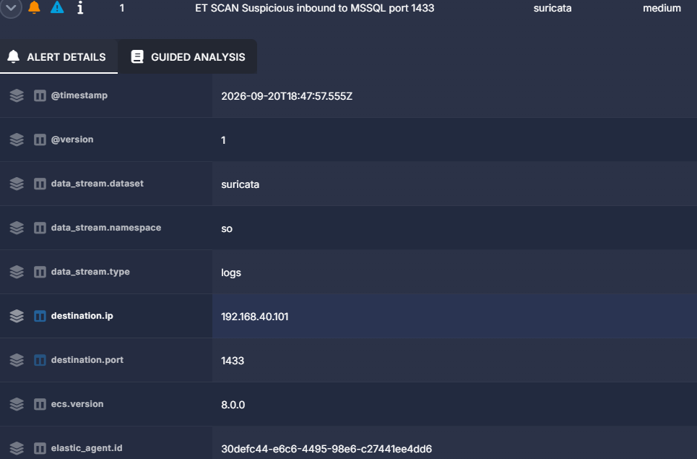
Figure 3.1 — Suricata Alert Triage: Investigation of the MSSQL scan alert identified Kali Linux (192.168.40.100) as the source, Windows 11 (192.168.40.101) as the destination, and TCP/1433 as the probed destination port.
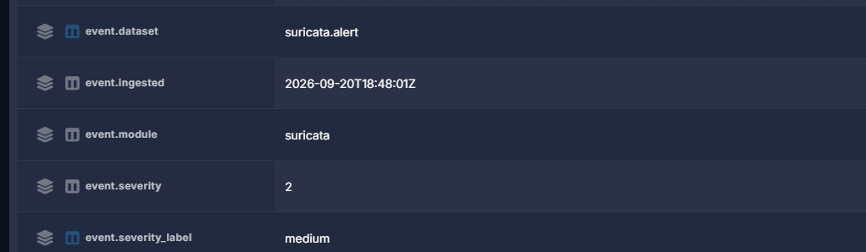
Figure 3.2 — Suricata Alert Triage: Investigation of the MSSQL scan alert identified Kali Linux (192.168.40.100) as the source, Windows 11 (192.168.40.101) as the destination, and TCP/1433 as the probed destination port.
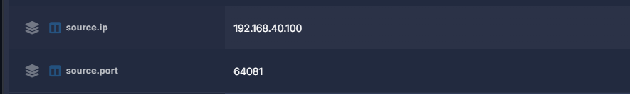
Figure 3.3 — Suricata Alert Triage: Investigation of the MSSQL scan alert identified Kali Linux (192.168.40.100) as the source, Windows 11 (192.168.40.101) as the destination, and TCP/1433 as the probed destination port.
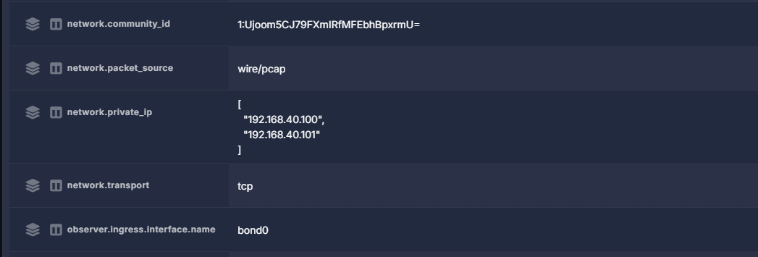
Figure 3.4 — Suricata Alert Triage: Investigation of the MSSQL scan alert identified Kali Linux (192.168.40.100) as the source, Windows 11 (192.168.40.101) as the destination, and TCP/1433 as the probed destination port.
Zeek Telemetry Correlation
To validate the reconnaissance activity using an additional data source, Security Onion Hunt was used to examine Zeek connection telemetry between the Kali Linux system (192.168.40.100) and the Windows 11 endpoint (192.168.40.101). The investigation focused on TCP ports 135, 139, and 445 because these were the three ports identified as open by the Nmap scan. Zeek connection records were observed for traffic from Kali Linux to all three destination ports, providing network-level evidence that corresponded with the Nmap scan results.
Hunt query we used:
source.ip:192.168.40.100 AND destination.ip:192.168.40.101 AND (destination.port:135 OR destination.port:139 OR destination.port:445)
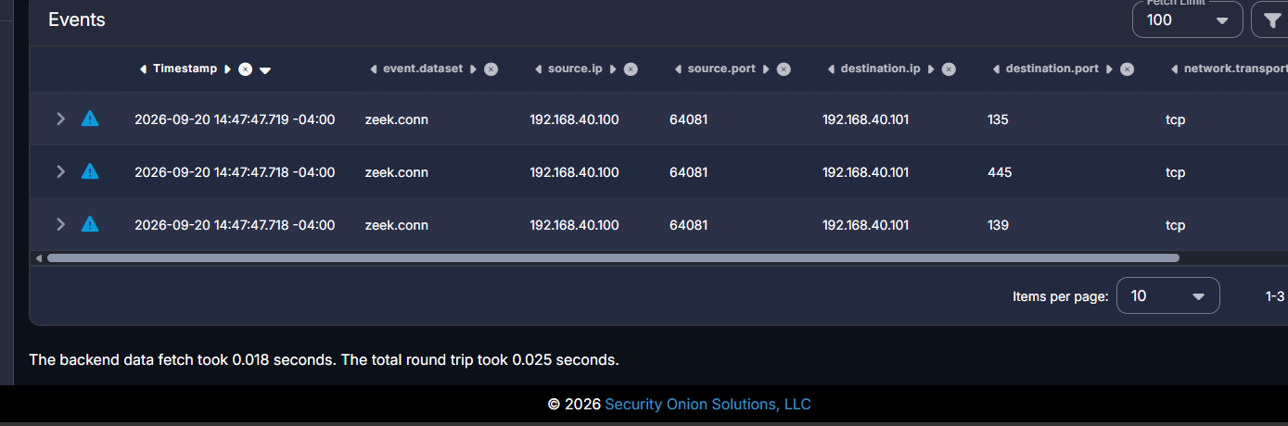Figure 4 — Zeek Connection Correlation: Zeek conn telemetry shows connections from Kali Linux (192.168.40.100) to the Windows 11 endpoint (192.168.40.101) on TCP ports 135, 139, and 445.
Step 58 — Analyze the TCP/445 Connection
Now we'll analyze one individual Zeek connection in more detail. This demonstrates that you can interpret connection-state telemetry, not just alerts.
Under the Zeek Telemetry Correlation section, add the heading:
TCP/445 Connection Analysis
The Zeek connection record associated with TCP/445 was examined in greater detail. TCP/445 is commonly associated with Microsoft SMB services. The connection originated from the Kali Linux system (192.168.40.100) and targeted the Windows 11 endpoint (192.168.40.101). Zeek recorded the connection state as RSTO, which indicates that the connection was established and the originator subsequently aborted the connection by sending a TCP reset (RST).
The connection contained two client packets and one server packet, representing a very small TCP exchange. When correlated with the authorized Nmap SYN scan, this behavior was consistent with reconnaissance rather than a normal sustained SMB session. Nmap had also reported TCP/445 as open on the Windows endpoint. The Zeek record therefore provided additional evidence of the scanner's interaction with TCP/445 during the reconnaissance activity.
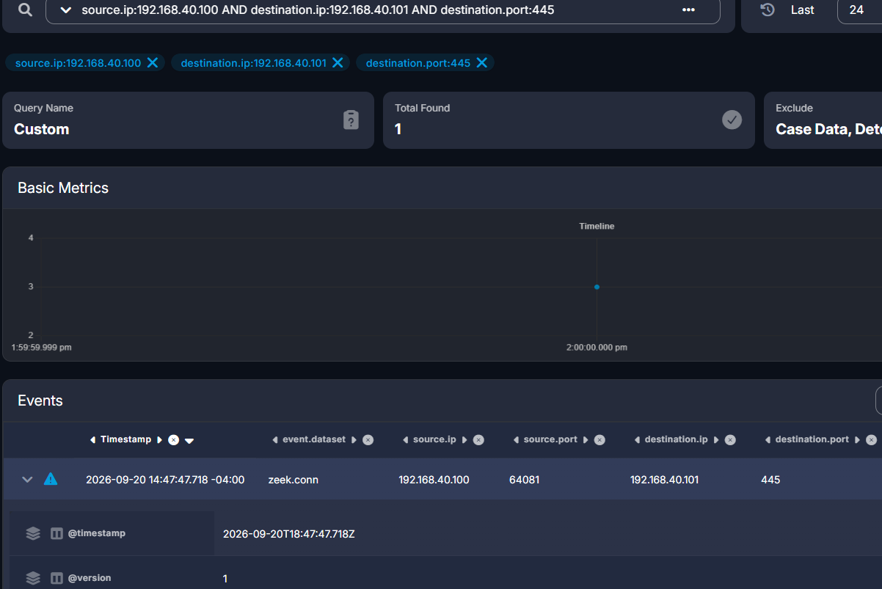Figure 5 — TCP/445 Zeek Connection: Zeek recorded the Kali-to-Windows TCP/445 connection with a connection state of RSTO, indicating that the originator reset the connection.
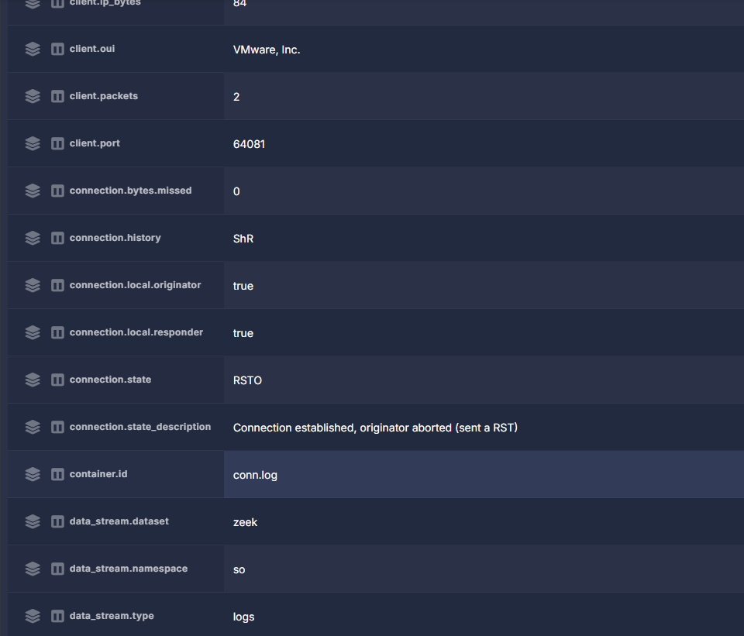 Figure 5.1 — TCP/445 Zeek Connection: Zeek recorded the Kali-to-Windows TCP/445 connection with a connection state of RSTO, indicating that the originator reset the connection
Final Analysis and Disposition
Then add:
Analysis of the collected evidence determined that the observed network activity originated from the Kali Linux system (192.168.40.100) and targeted the Windows 11 endpoint (192.168.40.101). Nmap identified TCP ports 135, 139, and 445 as open, while Security Onion recorded the associated network activity through Zeek and generated multiple scan-related detections through Suricata. Correlation of the source and destination addresses, destination ports, timestamps, IDS alerts, and Zeek connection telemetry was consistent with the authorized Nmap SYN scan performed during the lab exercise.
Then add:
No evidence collected during this investigation demonstrated exploitation, unauthorized access, malware execution, or compromise of the Windows 11 endpoint. The Suricata alerts represented detections of reconnaissance behavior rather than confirmation of a successful attack. Because the activity was intentionally generated as part of an authorized security exercise, the incident was classified as Expected Activity — Authorized Reconnaissance.
Finally, add this small summary table:
Field | Determination
Source | Kali Linux — 192.168.40.100
Target | Windows 11 — 192.168.40.101
Activity | TCP SYN reconnaissance
Tool | Nmap
Detection | Suricata
Network Telemetry | Zeek
Open Ports Identified | TCP/135, TCP/139, TCP/445
Severity | Medium scan-related detections observed
Evidence of Compromise | None identified
Final Disposition | Expected Activity — Authorized Reconnaissance
Lessons Learned and Skills Demonstrated
Then add:
This investigation provided hands-on experience with the complete process of generating, detecting, investigating, and documenting network reconnaissance activity. The exercise demonstrated how Nmap can be used to perform controlled reconnaissance and how Security Onion provides multiple sources of evidence for analyzing that activity. Suricata provided signature-based alerts, while Zeek supplied detailed network connection telemetry that allowed the activity to be independently examined and correlated. The investigation also reinforced the importance of establishing context before classifying security alerts, because the presence of an IDS detection does not automatically indicate a successful attack or system compromise.
Then add this list:
Skills Demonstrated
- Security Onion monitoring and investigation
- Suricata IDS alert triage
- Zeek network telemetry analysis
- Nmap TCP SYN scanning
- TCP/IP and port analysis
- Source and destination IP correlation
- Network connection-state analysis
- Multi-source event correlation
- False-positive/expected-activity determination
- SOC investigation documentation
- VMware virtual networking
- pfSense routing and firewall configuration
Finish with:
Key Takeaway: Effective SOC analysis requires more than identifying an alert. An analyst must validate the activity using available telemetry, correlate evidence across multiple data sources, understand the network context, and determine whether the activity represents malicious behavior, expected behavior, or requires further investigation.

